interface and migration

REQUIREMENTs TEMPLATE

**OASIS – PLM**

**Milestone:**

**Lot 2**

**Réf.:** **20061_12_00878**

|  |  |  |  |
| --- | --- | --- | --- |
| **MODIFICATIONS** | | | |
| Index | Date | Modifier | Subject |
| 1 |  |  | Creation with flow 1 functional details |
| 2 | 12 May 2014 | PA SIBERT | Flow 2 functional details |
| 3 |  | T PEYTAVIN | Updates and remarks |
| 4 | 11 June 2014 | PA SIBERT | Neutral format details |
| 5 | 2 July 2014 | PA SIBERT | Technical specifications |
| 6 | 4 July 2014 | PA SIBERT | Error management and pre or post processes |
| 7 | 15 July 2014 | S. DENIS | Updates of “Operability” and “Non-functional & technical requirements” |
| 8 | 17 July 2014 | PA SIBERT | Update on XSD files + New WSDL file |
|  |  |  |  |

Table of contentS

1. Introduction 4

1.1 Purpose of the document 4

*2* Organisation 5

*2.1* Actors and activities 5

2.2 PSA/I + DS/GP - Distribution 6

2.3 Redaction aid 6

3 General functional requirements 7

3.1 PSA/I --- Context and perimeter 7

3.2 PSA/I --- Data flow and data migrations list 8

3.2.1 Functional 8

3.2.2 Technical 8

4 Data flow n°1 Requirements 9

4.1 Functional specifications 9

4.1.1 Functional requirements 9

4.1.2 PSA/I ou DS/GP --- Functional Data Model 15

4.1.3 PSA/I + DS/GP+DS/I --- Data Flow Characteristics 19

4.1.4 PSA/I --- Data flow stability 20

4.1.5 PSA/I --- Data flow criticity 20

4.2 General technical specifications 21

4.2.1 PSA/I et DS/I --- Neutral format 21

4.2.2 DS/I+DS/GP --- PLM half-connector 21

4.2.3 PSA/I et DS/I --- Global data flow architecture 24

4.2.4 PSA/I --- Non-functional and technical requirements 24

4.2.5 PSA/I et DS/I --- DS half-connector complexity 25

4.2.6 Operability 26

4.2.7 PSA/I --- Security considerations 28

4.3 PSA/I --- Validation plan 28

4.3.1 Functional and technical tests strategy 28

4.3.2 Representative dataset 29

5 Data flow n°2 Requirements 30

5.1 Functional specifications 30

5.1.1 Functional requirements 30

5.1.2 PSA/I ou DS/GP --- Functional Data Model 32

5.1.3 PSA/I + DS/GP+DS/I --- Data Flow Characteristics 33

5.1.4 PSA/I --- Data flow stability 34

5.1.5 PSA/I --- Data flow criticity 34

5.2 General technical specifications 35

5.2.1 PSA/I et DS/I --- Neutral format 35

5.2.2 DS/I+DS/GP --- PLM half-connector 35

5.2.3 PSA/I et DS/I --- Global data flow architecture 36

5.2.4 PSA/I --- Non-functional and technical requirements 37

5.2.5 PSA/I et DS/I --- DS half-connector complexity 38

5.2.6 Operability 38

5.2.7 PSA/I --- Security considerations 41

5.3 PSA/I --- Validation plan 41

5.3.1 Functional and technical tests strategy 41

5.3.2 Representative dataset 41

6 Common technical reference/constraints for all flows 42

7 Terminology 42

# Introduction

## Purpose of the document

The objective of this document is to define the completeness of all data flow ( including data migrations) to implement between the existing PSA Information System named OASIS and the PLM for the Phase 1 – Lot 2 milestone. After validation, this document will be fixed and considered as the reference version. It will be copied and included according to the evolution foreseen for the following stages through the new document. Documents will be managed (versioning) in the DOCINFO database (PSA document Information System).

A data flow concerns a data exchange from an existing information system to a PLM module (or vice versa)

A data migration is a punctual operation that can be automated to facilitate Export / Transformation / massive Import operations.

A data flow or data migration can require a functional and\or technical transformation of the data when existing Information System data models are not well-matched with the PLM model.

For every data flow and data migration, the objective consists of describing both functional and technical specifications needed for the half-connector’s development:

* PLM half-connector: Dassault Systèmes responsibility
* Existing IS half-connector: PSA responsibility

# Organisation

## Actors and activities

|  |  |  |  |  |
| --- | --- | --- | --- | --- |
| *R: Responsable*  *A: Approving*  *S: Support*  *I: Information*  *C: Check* | Activities | Functional requirements | Technical requirements | validation , start-up and ramp-up scenario |
| **Acteurs PSA** |  |  |  |  |
| RIP MOA | Functional requirements, validation plan , start-up and ramp-up scenario | R |  | R |
| RIP MOE | Functional and technical requirements | S | C | S |
| Pilote Fonctionnel de l’Application | RIP MOA support, test dataset definition | S |  | S |
| Analyste SI (REA/CPI/aMOA) | RIP MOE support, test dataset definition | S | S | S |
| Pilote domaine MOA | Functional validation | C |  | C |
| Architecte fonctionnel MOE | Functional context | S/C |  |  |
| stratégie interface & migration MOA | Prioritization,animation, validation | A |  |  |
| stratégie interface & migration MOE | Prioritization,animation, validation | C | A |  |
| Chargé de conception | *Technical requirements* | C | R | (S) |
| Architecte technique MOE | Technical infrastructure, qualification techique |  | S | S/C |
| Responsable stratégie de tests | Tests strategy |  |  | A |
| Industrialisateur | Operability |  | S | S |
| exploitation en vie courante | Operability check |  | C | C |
| **Acteurs Editeur** |  |  |  |  |
| Global Solution Architect | Functional validation | A |  |  |
| Solution Architect du Groupe de Process | Business Process identification  Functional scenario  Dysfunctional scenario | R |  |  |
| Software Architect du groupe de Process | Data Model PLM |  | C |  |
| Industry process Consultant du groupe de Process | Test plan  traceability matrix  tests dataset |  |  | R |
| Architecture IT | Technical infrastructure |  | S |  |
| Global Software Architect | Technical validation | C | S |  |
| Global Interface Software Architect | Technical solution checking and validation |  | A |  |
| Interface (ieme) Software Architect | Technical solution definition | C | R |  |
| Testeur Interface (i) | Tests plan realization on integration environment |  |  | R |
| Responsable intégration | Opérability |  | S |  |

## PSA/I + DS/GP - Distribution

Distribution list

|  |  |
| --- | --- |
| ***To*** | ***Title*** |
| Eric LE DANTEC | RIP MOA |
| Marie-Laure STRADY | RIP MOE |
| Tiphaine GIANNA | Pilote Fonctionnel de l’Application |
| Pierre-Antoine SIBERT | Analyste SI (REA/CPI/aMOA) |
| Patrice POTIEZ | Pilote domaine MOA |
| Frédéric HARROUET | Architecte fonctionnel MOE |
| Véronique LEFEVRE | stratégie interface & migration MOA |
| Eric LAMBERT | stratégie interface & migration MOE |
| Pierre-Antoine SIBERT | Chargé de conception |
| Antony ANDRE | Architecte technique MOE |
| Jérôme LACOUR | Responsable stratégie de tests |
| Sébastien DENIS | Industrialisateur |
| Didier VICTOR | exploitation en vie courante |

## Redaction aid

To guide the different actors in the drafting of the document, the tittle of chapters is prefixed:

* PSA / I: is the PSA contract driver interface
* DS / I DS is the driver interface contract
* DS /GP: is the corresponding DS GP concerned

Some chapters are co-written.

Useful:

* Display the navigation menu (View / Navigation)
* In the 'search' part of 'navigation', indicate the role of the editor (PSA / I or DS / I or DS/ GP)
* Chapters / sub-chapters to write are highlighted

# General functional requirements

## PSA/I --- Context and perimeter

* Information system definition
  + Information system: **OASIS**
  + PLM module: **Requirement Central**
* IS Overview
  + Synoptic

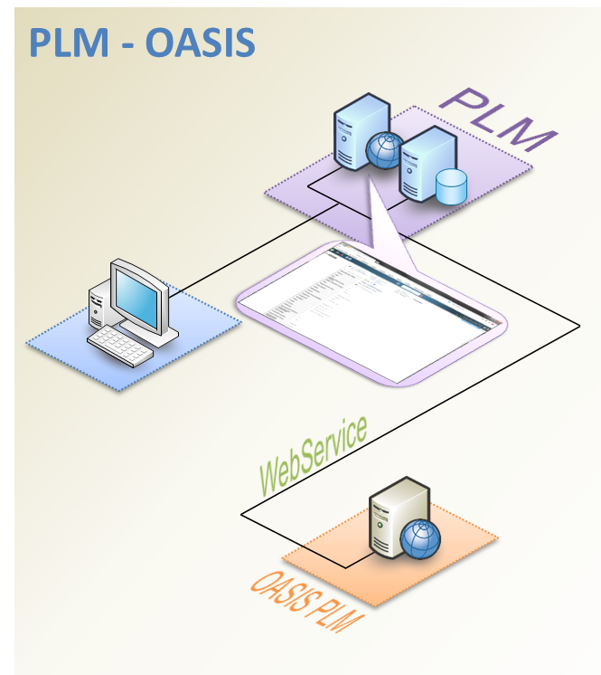

* + Description

OASIS/PLM is the dedicated solution of OASIS for PLM. It is a statistical calculation tool used to conform and validate design criteria of technical requirements. Tolerance attributes of related requirements are provided as input data and, based on an input mathematical formula, computations are executed and retrieved to PLM as output data for each requirement involved in the formula.

* Data responsibility (IS data owner, precise if ownership transfert)

PLM

* Macro Use-cases, functions and requirements in association with this interface

**SD5b_5 Allouer les exigences (fonctionnelles de performance industrielles) aux constituants**

* IS Version identification « system name »: **OASIS/PLM V1.0**
* PLM Version identification: **PLM Phase 1 Step 2.1**

## PSA/I --- Data flow and data migrations list

### Functional

|  |  |
| --- | --- |
|  | Description |
| Data flow 1 | Realize statistical calculations |
| Data flow 2 | Verify Transfer Model formula |

### Technical

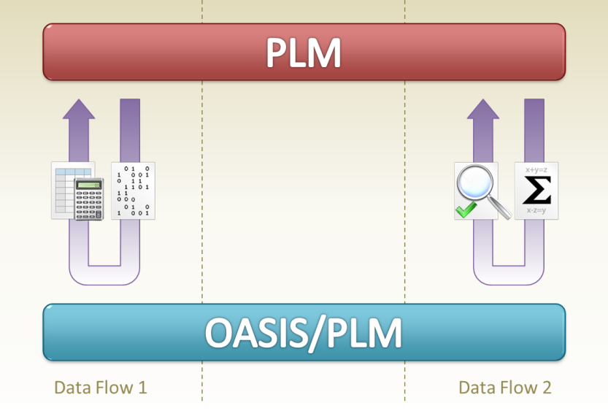

|  |  |  |
| --- | --- | --- |
|  | Technical Explanation | Périodicité et industrialisation |
| Data flow 1 | Web Service between PLM and OASIS:   * PLM sends Requirements and Transfer Models content to OASIS * OASIS computes statistical analysis on sent data and generates an HTML report with all results * OASIS sends back results and URL of HTML report to PLM | On demand from and to PLM specific UI  Frequency is 1 call per hour on average up to 50 calls per minute in extreme conditions  Up to 300 requirements data exchanged by call |
| Data flow 2 | Web Service between PLM and OASIS:   * PLM sends formula stored in Transfer Model to OASIS * OASIS checks formula * OASIS sends back result of check to PLM | On demand from and to PLM specific UI  Frequency is 1 call per day on average up to 3 calls per minute in extreme conditions  1 formula exchanged for each call |

# Data flow n°1 Requirements

## Functional specifications

### Functional requirements

#### PSA/I --- Functional overview

* Overview

**Interface between the PLM and OASIS to realize calculations**

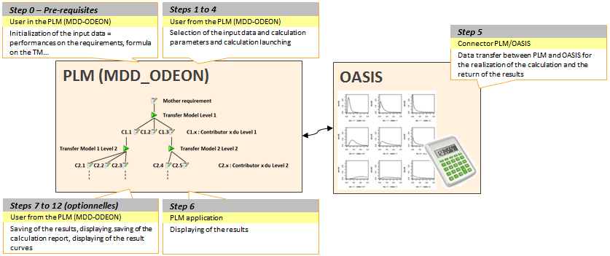

* + Producer short description

PLM is the producer of tolerance data to be computed by OASIS/PLM: these data comes from CTF/CSE Requirement and Transfer Models objects of Enovia Web – Requirement Central. These values are displayed in a specific webpage compiling all required items to send to OASIS/PLM. This specific UI is also used to select statistical analysis strategy to execute, to launch OASIS/PLM computations and to display OASIS/PLM statistical analysis results and completed Requirements tolerance values.

* + Consumer short description

OASIS/PLM receives tolerance values of requirements and applies statistical analysis strategy on sent data. Available strategies are:

* Monte Carlo simulation
* Tolerance Interval specification
* Arithmetic calculation
* Semi-quadratic calculation

##### Functional perimeter

* Explanations
  + Flow start

From Requirement Central (Enovia Web), PLM is collecting data from a collection of CTF/CSE Requirements connected by a Transfer Model with a mathematical formula as one of its attributes.

The User selects one kind of statistical analysis strategy for these requirements.

These data are set in data lists transferred to OASIS for statistical computation.

* + Intermediate Treatment

OASIS/PLM receives data lists, mathematical formula and statistical analysis strategy from PLM.

Based on these data, OASIS/PLM realizes some computations and generates related graphs and report.

OASIS/PLM sends to PLM statistical results and links to graphs and report.

* + Flow end

OASIS/PLM sends to PLM statistical results and links to graphs and report.

PLM display these data.

##### + DS/GP --- Use-cases

* ***SD5b_5 Allouer les exigences (fonctionnelles de performance industrielles) aux constituants***
* Vérifier les Spécifications Techniques Produit
* Vérifier et valider les spécifications par calcul / essais
* Mettre à jour le PIV Produit et les dossiers de conception
* ***DD2_5 Réaliser les plans fonctionnels et le dossier de conception***
* Récupérer les définitions produits et livrables associés des fournisseurs et gérer les exigences en adaptant et quantifiant les modèles de transfert associés
* Vérifier la tenue des objectifs prestations pour chaque composant spécifique RO

##### + DS/GP --- Nominal scenario

* Prerequisites

A Requirements Structure is defined: CTF/CSE Requirements connected with others through a Model Transfer with a mathematical formula. Dimensioning and Tolerance attributes of Requirement objects are filled in.

1. Select a Requirement in Requirements Structure
   1. Launch Calculation screen is displayed
2. Select a Calculation Strategy and related parameters
   1. Display of related Requirements Structure(s)
3. OPTIONAL – If several Structures, select Requirements Structure to analyse
   1. Display selected Requirements Structure, and Dimensioning and Tolerance attributes of all Requirements underneath
4. Request Calculation on previously selected data
   1. Format data for exchange with OASIS
   2. **DS Half connector:** Send request with formatted data to OASIS
   3. **DS Half connector:** Receive calculation results from OASIS
   4. **DS Half connector:** Receive Report result (http address) from OASIS
   5. Display calculation results and highlight updated values
5. Close Launch Calculation screen without saving

##### + DS/GP --- Alternative scenario

* Prerequisites

A Requirements Structure is defined: CTF/CSE Requirements connected with others through a Model Transfer with a mathematical formula. Dimensioning and Tolerance attributes of Requirement objects are filled in.

1. Select a Requirement in Requirements Structure
   1. Launch Calculation screen is displayed
2. Select a Calculation Strategy and related parameters
   1. Display of related Requirements Structure(s)
3. OPTIONAL – If several Structures, select Requirements Structure to analyse
   1. Display selected Requirements Structure, and Dimensioning and Tolerance attributes of all Requirements underneath
4. Update Requirements’ attributes values
   1. Highlight updated values
5. Request Calculation on previously selected data
   1. Format data for exchange with OASIS
   2. **DS Half connector:** Send request with formatted data to OASIS accordingly to the Calculation_Type
   3. **DS Half connector:** Receive calculation results from OASIS
   4. **DS Half connector:** Receive Report result (http address) from OASIS
   5. Display calculation results and highlight updated values
6. Visualize Calculation charts and graphs
   1. Display a specific popup window with requested charts generated by OASIS
7. Close charts popup window
8. Visualize Calculation report
   1. Display a specific popup window with requested report
9. Save the report on computer
10. Close report popup window
11. Save Calculation results and User updates.
    1. Display status of data saving in database
12. Close Launch Calculation screen

##### Data flows sequence

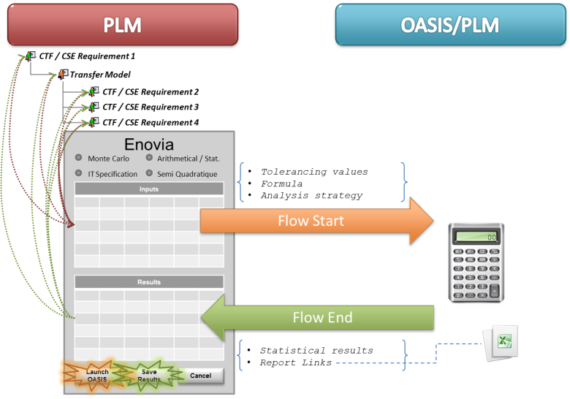

#### DS/GP --- Producer Half Connector Functional Requirements

* Prerequisites

In the GUI:

* + A Requirements (CTF/CSE) is selected.
  + A Calculation Strategy is selected:

|  |  |
| --- | --- |
| ***MONTE-CARLO*** |  |
| ***SPEC-IT*** |  |
| ***ARITHMETIC*** |  |
| ***SEMI-QUADRATIC*** |  |

* + The Calculation attributes are set
  + The Calculation starts (Command in GUI)
* Pre-treatments
  + The Command in GUI that runs the Calculation does
    - Identify the Starting Requirement (CFT/CSE)
    - Identify the Business Objects to send, according to the Calculation Strategy
    - Sends to OASIS
      * all CalculationAttributes_OASIS for identified Requirements
      * all Formula for identified Transfer Model (TM)
      * Parent ID of each object
* Post-treatments
  + OASIS sends back
    - All CalculationAttributes_OASIS for identified Requirements
    - A Boolean value per Requirement to identify which Requirement does not meet the conditions of the Calculation Strategy
    - All Formula for identified Transfer Model (TM)
    - A Boolean value per Transfer Model (TM) to identify which Transfer Model (TM)does not meet the conditions of the Calculation Strategy
    - Parent ID of each object
    - Error Message Code:
      * When Calculation conditions are not met
      * When Infinite results is found
      * When Calculation is not able to propose appropriated values for CalculationAttributes of all Requirements (CTF/CSE)
    - Error Code (Successful/Not Successful Boolean)
    - Link to the html report generated by OASIS on OASIS server.
  + Half Connector does:
    - When Successful:
      * Update all the attributes of the objects
      * Check-in the file (HTTP URL link) into Document OASIS_Rapport
        + If not existing create the Document object and link to Starting Requirement using “Reference Document” relationship
        + Rename the file and Check-in (format = generic): _temp_RAPPORT_OASIS_AAAAMMDD-HH:MM:SS
    - When Not Successful: Update the Calculation Flag Boolean (PSA_OASIS_CALCULATIONFLAG) of the objects
    - Sends to GUI (Command) the Message (See Table “Error Message Code” => “Message”) and the Error Code.
  + GUI does (out of scope of this contract)
    - Refresh the window to display updated values
    - Display the result:
      * When Successful: Error Message in information popup
      * When Not Successful: Error Message in warning popup
* Graphic User Interface (GUI) needs ***(implementation out of interface scope)***
  + Selection of data to send to OASIS:
    - Transfer Model (TM)
    - CTF and CSE Requirements connected to the “TM”
    - Calculation_Type (MONTE-CARLO, SPEC-IT, ARITHMETIC, SEMI-QUADRATIC)
  + The GUI is ready to launch the calculation: RUN OASIS CALCUATOR

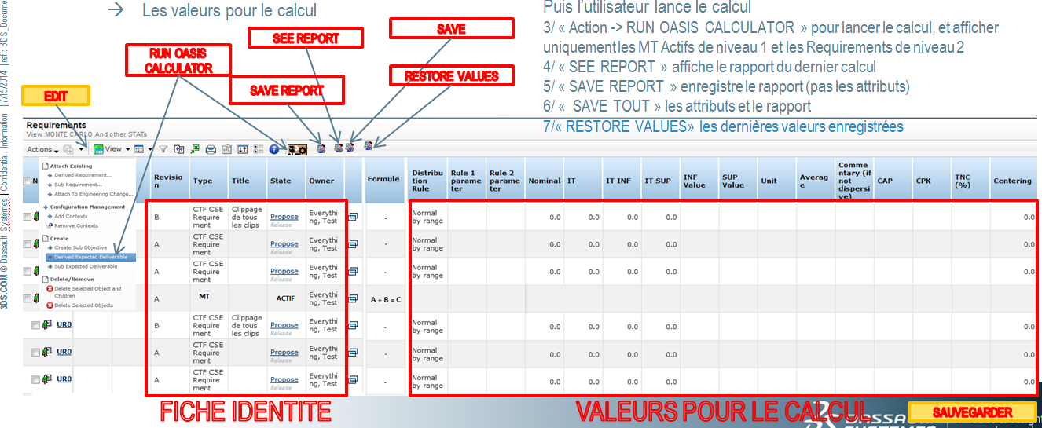

* + The Interface will send the following data to OASIS:

|  |  |  |  |
| --- | --- | --- | --- |
| ***Calculation_Type*** | ***Transfer Model*** | ***“Sister” CTF/CSE Requirement(s)*** | ***“Mother” CTF/CSE Requirement(s)*** |
| * Formula * Parent ID * ID | * ID * Parent ID (when the CFT/CSE Requirement is the starting Requirement: set Parent ID to ID) * All calculation attributes | * ID * All calculation attributes |
| ***MONTE-CARLO*** | YES, all levels (max 5 levels of TM) | YES, all levels (up to 5 levels of CTF/CSE Requirement) | NO |
| ***SPEC-IT*** | YES (1 level up from Start Requirement) | YES (same up as Start Requirement) | YES (2 levels up from Start Requirement) |
| ***ARITHMETIC*** | YES, (1 level of TM) | YES, (1 level of CTF/CSE Requirement from TM) | NO |
| ***SEMI-QAUDRATIC*** | YES, (1 level of TM) | YES, (1 level of CTF/CSE Requirement from TM) | NO |

* + Display
    - After reception of OASIS Calculation results, in specific case of Arithmetical and Semi Quadratic calculation types, user chooses 1 option between 2 or 3 options of results: Arithmetical, Statistical or Semi Quadratic tolerance values. OASIS always sends all possibilities for these calculation types.
      * Depending of the selected option, objects attributes are filled in with according results.
    - Otherwise user has no choice to do and the only option is automatically selected to update objects’ display.
  + Update of data received from OASIS (real time)
    - User clicks on Save button to store displayed data in database
    - Parameters calculation (before/after) of the CTF & CSE
    - Calculation Report link
  + OASIS Calculation report display
  + Storage of received / updated data

#### PSA/I --- Consumer Half Connector Functional Requirements

* Prerequisites

N/A

* Pre-treatment

|  |  |  |
| --- | --- | --- |
| ***STEP*** | ***Calculation_Type*** | ***Pre-Treatment*** |
| **1** | ***All (MONTE-CARLO, …)*** | Transfer Model (state =Active) formula:   * Check formula presence * Check formula conformity (Flow 2) |
| **2** | ***MONTE-CARLO*** | Lowest contributors: (CTF/CSE Requirement)   * Presence (not empty) of a Distribution law with related parameters |
| ***SPEC-IT*** | * “Mother” CTF/CSE Requirements:   + Presence (not empty) of low value, high value   + and at least one the following:     - CAP,     - %TNC     - Off-centring * “Sister” CTF/CSE Requirements:   + presence of a Distribution law with     - related parameters     - presence (not empty) of low value     - presence (not empty) of high value |
| ***ARITHMETIC*** | * “Mother” CTF/CSE Requirements:   + presence of     - %TNC * “Sister” CTF/CSE Requirements:   + presence of a Distribution law with     - related parameters     - presence (not empty) of nominal     - presence (not empty) of low value     - presence (not empty) of high value |
| ***SEMI-QUADRATIC*** | * “Mother” CTF/CSE Requirements:   + presence of     - %TNC     - CPK * “Sister” CTF/CSE Requirements:   + presence of a Distribution law with     - related parameters     - presence (not empty) of nominal     - presence (not empty) of low value     - presence (not empty) of high value     - presence (not empty) of high mean     - presence (not empty) of standard deviation |

In case one of these conditions (o) is not met, an alert is displayed to user. ***(Not in scope of the Interface Contract)***

* Post-treatment

Prepare data format before sending to PLM by avoiding particular situation or values such as decimal separator standardization, infinite values, etc…

TI Specifications exceptional cases: in case no result can be found with input data, a message is displayed to alert user.

* Graphic User Interface (GUI) needs

N/A

### PSA/I ou DS/GP --- Functional Data Model

#### Producer Data Model

|  |  |  |
| --- | --- | --- |
| ***Object*** | ***Attribute*** | ***Description*** |
| PSA_TransferModel | PSA_TM_Formula | Formula  See Rule Rp1 |
| PSA_OASIS_CALCULATIONFLAG (NEW ATTRIBUTE) | True if calculation succeed, False if not  Default value is True |

|  |  |  |
| --- | --- | --- |
| ***Object*** | ***Attribute*** | ***Description*** |
| User Requirement | PSA_Nominal_OASIS  PSA_Average_OASIS  PSA_StdDeviation_OASIS  PSA_InfValue_OASIS  PSA_SupValue_OASIS  PSA_InfTol_OASIS  PSA_SupTol_OASIS  PSA_TNC_OASIS  PSA_CAP_OASIS  PSA_CPK_OASIS  PSA_CenteringMax_OASIS  PSA_DistribRule_OASIS  PSA_Rule1Param_OASIS  PSA_Rule2Param_OASIS  PSA_IT_OASIS  PSA_InfTol_OASIS  PSA_SupTol_OASIS  PSA_IT_OASIS_1  PSA_InfTol_OASIS_1  PSA_SupTol_OASIS_1  PSA_IT_OASIS_2  PSA_InfTol_OASIS_2  PSA_IT_OASIS_3  PSA_InfTol_OASIS_3  PSA_SupTol_OASIS_3 | See Rule Rp0 & Rp1 |
| PSA_OASIS_CALCULATIONFLAG (NEW ATTRIBUTE) | True if calculation succeed, False if not  Default value is True |

|  |  |  |
| --- | --- | --- |
| ***Object*** | ***Attribute*** | ***Value*** |
| Document | Name | Autoname |
| Title | <Calculation_Type>_AAAAMMJJ_HHMMSS  Where Calcutation_Type is « MonteCarlo », « SpecIT », « Arithmetic/Statistic »,« Semi-Quadratic » |
| Document_Category | Rapport_OASIS |
| ***Others*** | ***Value*** |
| Policy | PSA_Document |
| State | Release (TBC) |
| Format | Generic |

|  |  |  |  |  |
| --- | --- | --- | --- | --- |
| ***Link*** | ***Attribute*** | ***Example*** | ***Mandatory*** | ***Description*** |
| Reference Document | N/A | N/A | N/A | N/A |

#### Producer Data Constraints

*Management rules, integrity or validity controls, extraction rules…)*

#### Consumer Data Model

**Monte Carlo Calculation**

|  |  |  |  |
| --- | --- | --- | --- |
| **Input** | | | |
| **Object** | **Attribute** | **Format** | **Condition** |
| Transfer model | Mathematical formula | String |  |
| Lowest contributor | Distribution law | Administrated list |  |
| Lowest contributor | Distribution law parameters | Real |  |
| Lowest contributor | Low value | Real |  |
| Lowest contributor | High value | Real |  |
| **Output** | | | |
| **Object** | **Attribute** | **Format** | **Condition** |
| Mother requirement | Mean | Real |  |
| Mother requirement | Standard-deviation | Real |  |
| Mother requirement | TNC% | Real | If Low value and/or High value is defined on the lowest contributor(s) |
| Mother requirement | Low value | Real | If Low value and High value are defined on the lowest contributor(s) |
| Mother requirement | High value | Real | If Low value and High value are defined on the lowest contributor(s) |
| Mother requirement | CAP | Real | If Low value and High value are defined on the lowest contributor(s) |
| Mother requirement | CPK | Real | If Low value and High value are defined on the lowest contributor(s) |
| Mother requirement | Off Centring | Real | If Low value and High value are defined on the lowest contributor(s) |
| Mother requirement | Calculation report | File .xlsx |  |
| Lowest contributor | CAP | Real | If Low value and High value are defined on the lowest contributor(s) |
| Lowest contributor | CPK | Real | If Low value and High value are defined on the lowest contributor(s) |
| Mother requirement | Mean | Real |  |

**Tolerance Interval specification**

|  |  |  |  |
| --- | --- | --- | --- |
| **Input** | | | |
| **Object** | **Attribute** | **Format** | **Condition** |
| Transfer model | Mathematical formula | String |  |
| Contributor | Distribution law | Administrated list |  |
| Contributor | Distribution law parameters | Real |  |
| Contributor | Low value | Real |  |
| Contributor | High value | Real |  |
| Mother requirement | Low value | Real |  |
| Mother requirement | High value | Real |  |
| Mother requirement | CAP and/or TNC% and/or Off Centring | Real |  |
| **Output** | | | |
| **Object** | **Attribute** | **Format** | **Condition** |
| Contributor | Low value | Real |  |
| Contributor | High value | Real |  |
| Contributor | Calculation report | File .xlsx |  |
| Mother requirement | Mean | Real |  |
| Mother requirement | Standard-deviation | Real |  |
| Mother requirement | CAP | Real |  |
| Mother requirement | CPK | Real |  |
| Mother requirement | TNC% | Real |  |
| Mother requirement | Off Centring | Real |  |

**Arithmetic Statistical Calculation**

|  |  |  |  |
| --- | --- | --- | --- |
| **Input** | | | |
| **Object** | **Attribute** | **Format** | **Condition** |
| Transfer model | Mathematical formula | String |  |
| Contributor | Nominal value | Real |  |
| Contributor | Low TI | Real |  |
| Contributor | High TI | Real |  |
| Mother requirement | TNC% | Real |  |
| **Output** | | | |
| **Object** | **Attribute** | **Format** | **Condition** |
| Mother requirement | Nominal value | Real |  |
| Mother requirement | Arithmetical TI | Real |  |
| Mother requirement | Arithmetical Low TI | Real |  |
| Mother requirement | Arithmetical High TI | Real |  |
| Mother requirement | Statistical TI | Real |  |
| Mother requirement | Statistical Low TI | Real |  |
| Mother requirement | Statistical High TI | Real |  |
| Mother requirement | Off Centring | Real |  |
| Mother requirement | Calculation report | File .xlsx |  |

**Semi Quadratic Calculation**

|  |  |  |  |
| --- | --- | --- | --- |
| **Input** | | | |
| **Object** | **Attribute** | **Format** | **Condition** |
| Transfer model | Mathematical formula | String |  |
| Contributor | Nominal value | Real |  |
| Contributor | Low value | Real |  |
| Contributor | High value | Real |  |
| Contributor | Mean | Real |  |
| Contributor | Standard-deviation | Real |  |
| Mother requirement | TNC% | Real |  |
| Mother requirement | CPK | Real |  |
| **Output** | | | |
| **Object** | **Attribute** | **Format** | **Condition** |
| Mother requirement | Nominal value | Real |  |
| Mother requirement | Arithmetical TI | Real |  |
| Mother requirement | Arithmetical Low TI | Real |  |
| Mother requirement | Arithmetical High TI | Real |  |
| Mother requirement | Statistical TI | Real |  |
| Mother requirement | Statistical Low TI | Real |  |
| Mother requirement | Statistical High TI | Real |  |
| Mother requirement | Semi-quadratic TI | Real |  |
| Mother requirement | Semi-quadratic Low TI | Real |  |
| Mother requirement | Semi-quadratic High TI | Real |  |
| Mother requirement | Off Centring | Real |  |
| Mother requirement | Calculation report | File .xlsx |  |

#### Consumer Data Constraints

See §4.1.1.3

#### Consumer Data Prerequisites

N/A

#### Functional Data Mapping

##### Object Mapping

|  |  |  |
| --- | --- | --- |
| ***Consumer Object*** | ***Consumer attribute*** | ***Creation rules from Producer data (Transformation , cardinality, …)*** |
| CTF / CSE Requirement |  | 1 - 1 |

##### Link Mapping

|  |  |  |
| --- | --- | --- |
| ***Consumer Link*** | ***Consumer attribute*** | ***Creation rules from Producer data (Transformation , cardinality, …)*** |
| N/A |  |  |

##### Data Mastership

|  |  |  |
| --- | --- | --- |
| ***Data*** | ***Mastership*** | ***Description/Rules*** |
| CTF / CSE Requirement | PLM |  |

### PSA/I + DS/GP+DS/I --- Data Flow Characteristics

#### Volume

|  |  |
| --- | --- |
|  | Volume (No. Object, attributes to be transmitted etc…) |
| Object #1 | Up to 5 levels of Transfer Model / Contributor for Monte Carlo Simulation and up to 300 contributor for Arithmetic Statistical calculation |
|  | Over 100 contributors under a Transfer Model |

#### Flow Activation

* Frequency

Up to 50 Calculation calls per minute

* Trigger event

Designer manual action in Enovia

#### Flow Constraints

* Delay and response time requirements

Less than 10sec for a call and its response

* Pre-conditions for data flow activation

Check if all mandatory data are set: if not, the request should not be sent

* Post-conditions

N/A

* Confidentiality

N/A

#### Flow Monitoring

* Monitoring needs

Functionality usage follow-up

**OUT OF CURRENT SCOPE** Availability check every day of the communication between PLM and OASIS/PLM: a batch runs the JPO program to call OASIS Web Service; in case of failure or incident, create an alert to PSA IT monitoring systems. *Check with Technical Integration Team how to handle this.*

### PSA/I --- Data flow stability

* Destabilization criteria if IS version planned (evolution planned and potential impacts identification )

No update expected on OASIS/PLM for the moment. In case of update, new project will include interface impacts analysis.

* Data flow life time (expected stop date)

OASIS replacement is on discussion but no target date is for the moment known

* Change management

N/A

### PSA/I --- Data flow criticity

* Users requirements

Highly expected usage during Project Convergence phase, lower criticality otherwise

Functional monitoring needs: Calculation types details on OASIS/PLM side

* Other flow impacts: N/A

## General technical specifications

|  |  |  |
| --- | --- | --- |
| ***Object type name in PLM*** | ***Object type label in English*** | ***Object type label in database*** |
| ***Requirement*** | “CTF CSE Requirement” | “User Requirement” |
| ***Transfer model*** | “Transfer model” | “PSA_TransferModel” |

### PSA/I et DS/I --- Neutral format

#### Definition



**ParentID of mother Requirements is their own ID**

#### Constraints

N/A

#### Samples

Embedded file, link to JIRA / Docinfo…

### DS/I+DS/GP --- PLM half-connector

#### Overview

For “Spec IT” calculation:

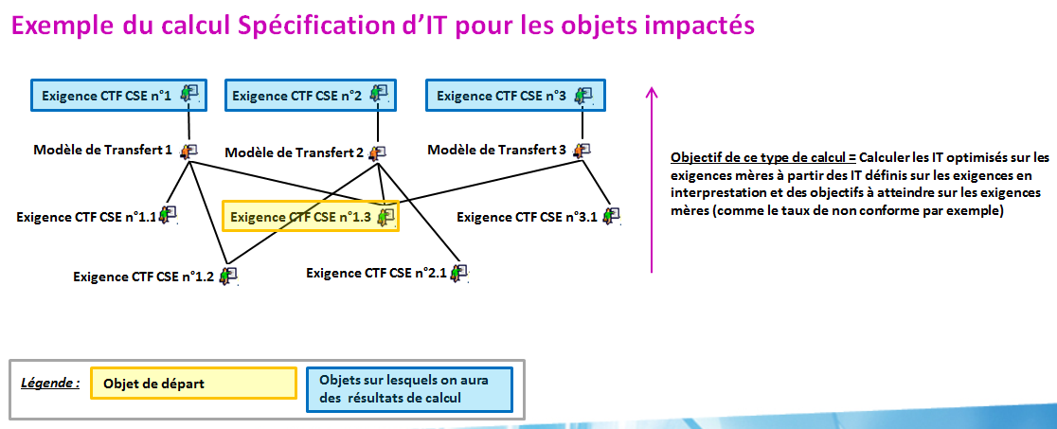

Find the Mothers, then expand mothers through “Active Transfer Model” to get all “CTF/CSE Requirements”: in the file it may be possible to have the same “CTF/CSE Requirement” repeated (see diagram).

For other calculations:

In the file it may be possible to have the same “CTF/CSE Requirement” repeated.

#### Data mapping

##### Object #1 – Transfer Model

###### Basics

|  |  |  |
| --- | --- | --- |
| ***Basics*** | ***Value*** | ***Transformation rule*** |
| Type | PSA_TransferModel |  |
| Name | N/A | AutoName: Size A |
| Revision | Revision | Autonum |
| Owner | User of the Batch |  |
| Policy | EC Part | Fixed |
| Current | See lifecycle correspondance |  |
| Vault | eService Production |  |
| Originated | User of the Batch |  |
| P&O (Organization) | PSA | See P&O rules / Règles P&O |
| P&O (Project) | Standard |  |

###### Attribute Mapping



###### Management rules

Creation

N/A

Deletion

N/A

Update

N/A

Revision

N/A

##### Object #2 – User Requirement

###### Basics

|  |  |  |
| --- | --- | --- |
| ***Basics*** | ***Value*** | ***Transformation rule*** |
| Type | User Requirement |  |
| Name | N/A | AutoName: Size A |
| Revision | Revision | Autonum |
| Owner | User of the Batch |  |
| Policy | EC Part | Fixed |
| Current | See lifecycle correspondance |  |
| Vault | eService Production |  |
| Originated | User of the Batch |  |
| P&O (Organization) | PSA | See P&O rules / Règles P&O |
| P&O (Project) | Standard |  |

###### Attribute Mapping



###### Management rules

Creation

N/A

Deletion

N/A

Update

N/A

Revision

N/A

##### Relationship #1 – Sub Requirement

###### Basics

|  |  |  |  |
| --- | --- | --- | --- |
| ***Basics*** | | ***Value*** | ***Conversion rule*** |
| ***Type*** | | Sub Requirement |  |
|  | ***From*** | User Requirement |  |
| ***To*** | PSA_TransferModel |  |
|  | ***From*** | PSA_TransferModel |  |
| ***To*** | User Requirement |  |

###### Attribute Mapping

|  |  |  |
| --- | --- | --- |
| ***Attribute on relationship*** | ***Value*** | ***Transformation Rule*** |
| *Find Number* | *FN* | *Count the number of already existing EBOM link of connection « From »*  *Increment by one to get FN* |
| *PSA_LegacySource* | *N/A* | *Fixed Value = « ARTICLE »* |
| *PSA_Mastership* | *N/A* | *Fixed Value = «  ARTICLE  »* |

###### Management rules

Creation

N/A

Deletion

N/A

Update

N/A

### PSA/I et DS/I --- Global data flow architecture

The choice of technical solution will be coherent with alternatives proposed by the matrix « PLM-IS PSA interface tools ». The choice made for this data flow is to explain in this section

#### Communication

* Communication layer

Web Service using WSDL messages

* Communication support

HTTPS

* Interconnection type

Synchronous and “Request – Response” type

* Extract

N/A

#### Security

* Login account (LDAP, technical login account)

A technical user account with appropriate permissions and allowed to connect to OASIS/PLM server will be used for the request.

#### Miscellaneous

* IT impacts:

Brand new OASIS/PLM server solution for these needs

* Solution sharing: re-using part or all of a technical solution already identified.
  + V6 side: no re-use
  + OASIS/PLM: re-use of existing algorithms and data structures of OASIS

### PSA/I --- Non-functional and technical requirements

* Response time and processing time objectives, measuring tool

Function must be executed within:

* + Default: 10s
  + Monte Carlo 5 levels: 30s
* Availability objectives, measuring tool

Service available at least between 7:00am and 8:00pm (Paris time)

* Capacitive and volume objectives, measuring tool

Must deal with up to 50 Calculation calls based on a range of 10 requirements per minute

* Data flow and data migration cohabitation

N/A

CAUTION: There should not be exceptions like "No file on public/bank holidays." Example: if files are to be sent / received from Monday to Saturday, then those files should be received on these days even if some of them are public/bank holidays.

CAUTION: Except in exceptional cases: no interface batch are running on the PLM servers between Saturday 18:00 and Sunday 18:00. This time slot is reserved for technical operations (maintenance, shutdown / restart ...).

### PSA/I et DS/I --- DS half-connector complexity

Complexity quotation is based on a model defined in the contract PSA-DS section Technical annexe. Data flows are classified on 3 levels: simple, medium and complex.

This quotation is based on exchanged data complexity:

* Simple, if data is atomic such as a character string or an integer. This is generally used to propagate a state of a master system to a slave system,
* Medium, if exchanged data granularity correspond to an object of the PLM data model,
* Complex, if exchanged data correspond to a structured dataset as a BOM.

Secondly, this quotation is based on treatment complexity:

* Simple, if Get/set operation or multiple attributes mapping,
* Medium, if create/update/delete operation
* Complex, if there is a recursive algorithm, a search, or a multi-criteria extraction

It is related also to the complexity of the technical solution implementation. This last criteria concern the data flow direction: unidirectional or bidirectional.

Finally, the half-connector complexity is classified as following:

Simple unidirectional

Medium unidirectional

Complex unidirectional

Simple Bidirectional

Medium Bidirectional

Complex Bidirectional

|  |  |  |  |
| --- | --- | --- | --- |
| ***Exchange data complexity*** | ***Treatment complexity*** | ***Uni-/bi-directional*** | ***Complexity classification*** |
| All values sent are in input, a validity check have to be performed  🡺 Medium | Search needed to find list of linked objects, creation and link based on answer.  🡺 Medium | bi-directional | Medium Birectionel |

### Operability

In response to business requirements

* **Development**
  + *All SI objects should fit to PSA naming conventions (CDE-2.1.2, PEXNF-5.1)*

[*DSIN-NM-CODOBJ01 Référentiel codification des objets de développement*](http://cascade.inetpsa.com/PrismaDoc/actions/redirect?method=attachment&ref=DSIN-NM-CODOBJ01&datasource=prisma)

[*DSIN-NM-UNX04 Unix*](http://cascade.inetpsa.com/PrismaDoc/actions/redirect?method=attachment&ref=DSIN-NM-UNX04&datasource=prisma)

* + *SI development respects the maintainability rules of its technology (CDE-3.3.1, PEXNF-5.1)*

The entire source code should be commented (header, variables initialization, error management …). Each program component starts with a header descripting at least: name, description, author name or service, Input/Output, date, list of updates.

* + *System is independent from any material physical names (CDE-3.2.1, PEXNF-5.2)*

Items that depend on environments usage or name (LDAP directory address, database hostname/login/password, verbosity level …) should be externalized in configuration files.

* + *System explicitly release resources when they are no longer needed (CDE-2.2.7, PEXNF-6.2)*

Used resources should remain manageable, even in case of planned abort.

Program should close opened files, direct connections to the database or to other applications … It should free all system resources used by its statements (memory, temporary files …

This item will be verified by load testing (covering performance testing and stress testing).

* + *Reading and writing functionalities are differentiated (CDE-2.2.4, PEXNF-6.1)*

Programs should allow data reading while they are modifying data (insert/update/delete). (For example: users can use the web application to read data while a batch is inserting new data). The reading process should remain available even if a writing statement aborts abnormally.

* + *Program components can manage empty or missing or unavailable technical resources (CDE-2.2.3, PEXNF-6.1)*

Applications should be able to handle/manage the following errors:

* + - Missing input/file/database
    - Empty input/file/database
    - Unavailable input/file/database/Web Service

allowing systematic & automatic planning.

* + *The system is built with respect to performance issues related to its technology and to the chosen infrastructure (CDE-3.1.1, PEXNF-4.1)*

The program execution time should stay below limits, allowing a good resources share and minimizing delay risks (including recovery time).

For example: optimization of SQL requests, indexes dedicated to the treatment (created at the beginning and dropped at the end), intermediate commits …

* + *The applicative and technical system components are tuned before the production start (CDE-2.2.1, PEXNF-6.1)*

Technical experts should verify and tune technical parameters (or have them validated by constructor experts or by software editors). Developers and integrators should verify and tune applicative parameters.

Load testing (covering performance testing and stress testing) should validate those parameters (for example: number of parallel threads, java min and max usage …)

* + *The system insures the functional integrity of its data and the coherence of handled data. (CDE-4.1.1 & 4.1.2, PEXNF-3.3)*

Only one application is the owner of a database and manages data updates. Any application owner must maintain the security and the integrity of its data, even if updates are done in parallel.

The application must ensure that each input data stream is coherent with regard to its expectations. Functional checks must be made within the application.

* + *All applications must be designed and developed to allow the upgrade of software products and operating system (CDE-3.2.4, PEXNF-5.2)*

An application must be independent of operating software and system: OS, operating software and applications must be able to evolve independently of each other.

The behavior of the application must be guaranteed in case of a software component upgrade (forward compatibility).

* **Monitoring - Supervision**

The following criteria will enable the proper usage of monitoring procedures – based on PSA Group tools – during components life, after the delivery.

* + *All applications & batch programs must be designed and developped to be continuously monitored by standard PSA monitoring tools. (CDE-1.3.1, PEXNF-3.4)*

All events that can disrupt the application should be monitored (unreceived files, absent process ...).

The failure of a data update should be written in a logfile and should generate an incident. Cf. Incidents generation process

Events used to anticipate failures should also be monitored (e.g.: database volume).

The monitoring log level should enable IT people to diagnose technical incidents and to perform targeted actions (other than brutal stop/start).

* + *Batch programs / Web Services end with the appropriate exit code (CDE-2.2.6, PEXNF-6.1)*

A program that ends successfully should return with exit code 0. A program that ends abnormally should return with a different exit code.

Cf. Incidents generation process

* + *Batch programs / Web Services publish detailed execution reports*

Program execution reports should be published in result or log files. Those reports will only be used for troubleshooting purpose.

* + *Batch programs / Web Services verbosity level should be customizable in configuration files*

The log level should be customizable in configuration files, to be quickly modified for troubleshooting purpose without having to reinstall the programs (for example: switch from INFO level to DEBUG level).

* **Re-engagement (error recovery), recovery procedures**
  + *System troubleshooting/maintenance document is up-to-date and available (CDE-1.4.1, PEXNF-5.4)*

All the possible errors should be described in a technical document with troubleshooting procedures (for example: direct re-launching (without any prerequisite), developers analysis required before any further action, parameter update in database, pertinent information in logs, …).

* + *System components should be able to handle predictable logical errors (fields control, parameter check, …) (CDE-2.2.5, PEXNF-6.1)*

All errors resolved by the applicative logic should be automatically written in log files.

* **Full data re-initialization (e.g. in case of corrupted data)**

N/A

* **Alternative operating mode and « disaster recovery plan » aspects**

N/A

* **Backup plan (rollback)**

N/A

INCIDENTS GENERATION PROCESS

* **For BATCH programs**
  + The program delivered to the indus (SHEL, JAVA, MQL …) should end with the appropriate exit code (=0 if it ends successfully, <>0 if an error occurs)
  + The indus script that integrates that program will generate an incident if the exit code is not 0 (“Night call to the indus permanence” or “Direct transfer to the indus (so incident will be treated during opening hours)” or “Direct transfer to developers”)
* **For interactive actions (users actions in the application)**
  + Display of an error message for the user, with information (e.g.: “Temporary problem, please try again in x minutes”, “Critical problem, please call the helpdesk”, “inconstancy detected, please call the application pilot” …)
* **For other treatments like asynchronous Web Services**
  + Two different solutions

1. PREFERRED SOLUTION: When an error occurs, the Web Service can launch an “outside script” (a script which is not in the application). That script can be managed by the indus and will generate the incident (by applying rules written in the DLEI. Cf. « REMINDER » below)

The Web Service must provide 2 required input parameters when calling the external script: 1st parameter = name of the application that calls the script (without spaces, without accent, all lowercase), 2nd parameter = error code (as a number).

If the Web Service provides more input parameters in this call, then these will be passed to the script and can be used in a specific way (detailed in DLEI) to aid in the diagnosis. /

Example: the third parameter passed may contain a reference to the item in error. In DLEI, it may be said that this reference should be forwarded in the title of the incident (automatically generated).

CAUTION: the path of the script and its name should be defined in a configuration file, in order to facilitate their update.

1. When an error occurs, the Web Service can create a specific logfile. The indus will write a script to generate an incident if that logfile is created.

CAUTION: a naming rule should be defined to allow the identification of the error logfiles (e.g.: “LogErr_<xxxxxx>.log”). The path of that error logs and the naming rule should be defined in a configuration file, in order to facilitate their update.

REMINDER: In all cases

Each possible exit code should be detailed in the DLEI: description, analysis method, correction guide, criticality …

### PSA/I --- Security considerations

Technical response to data confidentiality (detailed in section « functional data flow specifications »)

* On OASIS/PLM side a check will be set up on the user account’s rights to access server and especially calculation reports access.
* On V6 side, the PO and the implementation of the trigger will handle the security.

## PSA/I --- Validation plan

### Functional and technical tests strategy

* Unitary tests, stub
* End to end integration tests
* Load tests and technical qualification
* Tests automation?
* Tests traceability (use-case/tests matrix) and coverage rate
* Dysfunctional scenario and Alternative scenario tests
* Stress test strategy
* Hardware resources

Availability of pre-production environment

### Representative dataset

* Tests dataset creation scenario
* Re-usable and transversal tests dataset

In case of transversal tests dataset, necessary data will be identified

# Data flow n°2 Requirements

## Functional specifications

### Functional requirements

#### PSA/I --- Functional overview

* Overview

**Interface between the PLM and OASIS to verify a formula**

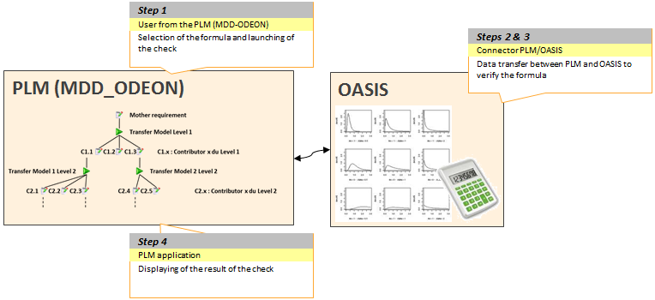

* + Producer short description

PLM is handling a mathematical formula related to a Transfer Model: there is no sign of its usability for statistical calculation with OASIS.

* + Consumer short description

OASIS/PLM receives Transfer Model’s mathematical formula and checks its syntax and its validity against OASIS rules.

##### Functional perimeter

* Explanations

From Requirement Central (Enovia Web), PLM is sending mathematical formula of Transfer Model. In return OASIS provides conformity status.

##### + DS/GP --- Use-cases

* ***SD5b_5 Allouer les exigences (fonctionnelles de performance industrielles) aux constituants***
* Décomposer la prestation en paramètres techniques influents Y = f(Xi) en définissant le modèle de transfert

##### + DS/GP --- Nominal scenario

* Prerequisites

A Transfer model is filled in with a mathematical formula.

1. Select the Transfer Model in Requirements Structure
   1. Display Transfer Model properties
2. Edit Transfer Model details and fill in a mathematical formula
3. Request Mathematical formula check
   1. Send request with mathematical formula to OASIS
   2. Receive check status from OASIS
   3. Display check status
4. Save Transfer model’s details update

##### + DS/GP --- Alternative scenario

* Prerequisites

A Requirements Structure is defined: CTF/CSE Requirements connected with others through a Model Transfer with a mathematical formula.

1. Select a Requirement in Requirements Structure
   1. Launch Calculation screen is displayed
2. Select a Calculation Strategy and related parameters
   1. Display of related Requirements Structure(s)
3. OPTIONAL – If several Structures, select Requirements Structure to analyse
   1. Display selected Requirements Structure, and Dimensioning and Tolerance attributes of all Requirements underneath
4. Select Transfer Model to check
   1. Highlight Transfer model’s mathematical formula
5. Request Mathematical formula check
   1. Send request with mathematical formula to OASIS
   2. Receive check status from OASIS
   3. Display check status
6. Update Mathematical formula according to check status
7. Save Mathematical formula changes.
   1. Display status of data saving in database
8. Close Launch Calculation screen

##### Data flows sequence

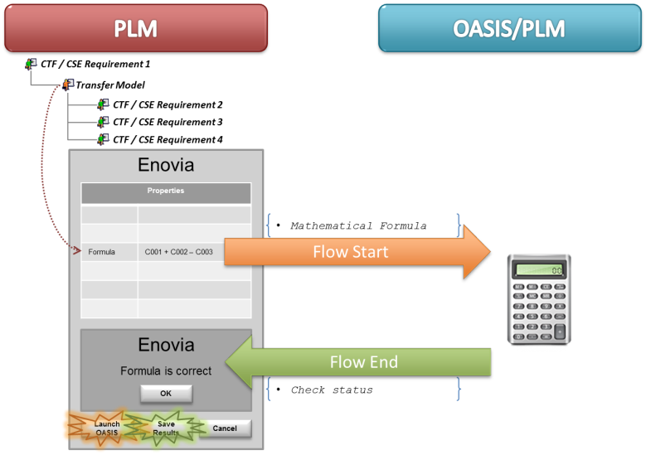

#### DS/GP --- Producer Half Connector Functional Requirements

* Prerequisites

Data model for Requirements need to be implemented in PLM database.

Transfer model with mathematical formula.

* Pre-treatments

N/A

* Post-treatments

N/A

* Graphic User Interface (GUI) needs ***(implementation out of interface scope)***

“Check Formula” button in Transfer model Properties screen and in Calculation Launch screen.

#### PSA/I --- Consumer Half Connector Functional Requirements

* Prerequisites

N/A

* Pre-treatment

N/A

* Post-treatment

N/A

* Graphic User Interface (GUI) needs

N/A

### PSA/I ou DS/GP --- Functional Data Model

#### Producer Data Model

|  |  |  |  |  |
| --- | --- | --- | --- | --- |
| ***Object*** | ***Attribute*** | ***Example*** | ***Mandatory*** | ***Description*** |
|  |  |  |  |  |

|  |  |  |  |  |
| --- | --- | --- | --- | --- |
| ***Link*** | ***Attribute*** | ***Example*** | ***Mandatory*** | ***Description*** |
|  |  |  |  |  |

#### Producer Data Constraints

*Management rules, integrity or validity controls, extraction rules…)*

#### Consumer Data Model

|  |  |  |
| --- | --- | --- |
| **Object** | **Attribute** | **Format** |
| Transfer model | Mathematical formula | String |

#### Consumer Data Constraints

*Management rules, integrity or validity controls, extraction rules…)*

#### Consumer Data Prerequisites

N/A

#### Functional Data Mapping

##### Object Mapping

|  |  |  |
| --- | --- | --- |
| ***Consumer Object*** | ***Consumer attribute*** | ***Creation rules from Producer data (Transformation , cardinality, …)*** |
| Transfer model | Mathematical formula | 1 - 1 |

##### Link Mapping

|  |  |  |
| --- | --- | --- |
| ***Consumer Link*** | ***Consumer attribute*** | ***Creation rules from Producer data (Transformation , cardinality, …)*** |
| N/A |  |  |

##### Data Mastership

|  |  |  |
| --- | --- | --- |
| ***Data*** | ***Mastership*** | ***Description/Rules*** |
| Transfer model | PLM |  |

### PSA/I + DS/GP+DS/I --- Data Flow Characteristics

#### Volume

|  |  |
| --- | --- |
|  | Volume (No. Object, attributes to be transmitted etc…) |
| Object #1 | 1 formula per Transfer model |

#### Flow Activation

* Frequency

Up to 3 Formula checks per minute

* Trigger event

Designer manual action in Enovia

#### Flow Constraints

* Delay and response time requirements

Less than 10sec for a call and its response

* Pre-conditions for data flow activation

Check if a mathematical formula is filled in Transfer model.

* Post-conditions

N/A

* Confidentiality

N/A

#### Flow Monitoring

* Monitoring needs

Functionality usage follow-up

### PSA/I --- Data flow stability

* Destabilization criteria if IS version planned (evolution planned and potential impacts identification )

No update expected on OASIS/PLM for the moment. In case of update, new project will include interface impacts analysis.

* Data flow life time (expected stop date)

OASIS replacement is on discussion but no target date is for the moment known

* Change management

N/A

### PSA/I --- Data flow criticity

* Users requirements

Highly expected usage during Project Convergence phase, lower criticality otherwise

Functional monitoring needs: Number of usages of the functionality on OASIS/PLM side

* Other flow impacts:

N/A

## General technical specifications

### PSA/I et DS/I --- Neutral format

|  |  |  |  |
| --- | --- | --- | --- |
| ***File-Parameter Name*** | ***Format*** | ***Encoding*** | ***Description*** |
| Input #1 | XML | UTF-8 | XSD available |

#### Definition



#### Constraints

N/A

#### Samples

*Embedded file, link to JIRA / Docinfo…*

### DS/I+DS/GP --- PLM half-connector

#### Overview

*Diagram + Treatment sequence*

#### Data mapping

##### Object #1 – Transfer Model

###### Basics

|  |  |  |
| --- | --- | --- |
| ***Basics*** | ***Value*** | ***Transformation rule*** |
| Type | PSA_TransferModel |  |
| Name | N/A | AutoName: Size A |
| Revision | Revision | Autonum |
| Owner | User of the Batch |  |
| Policy | EC Part | Fixed |
| Current | See lifecycle correspondance |  |
| Vault | eService Production |  |
| Originated | User of the Batch |  |
| P&O (Organization) | PSA | See P&O rules / Règles P&O |
| P&O (Project) | Standard |  |

###### Attribute Mapping



###### Management rules

Creation

N/A

Deletion

N/A

Update

N/A

Revision

N/A

##### Relationship #1

###### Basics

|  |  |  |  |
| --- | --- | --- | --- |
| ***Basics*** | | ***Value*** | ***Conversion rule*** |
| Type | | Sub Requirement |  |
|  | From | User Requirement |  |
| To | PSA_TransferModel |  |
|  | From | PSA_TransferModel |  |
| To | User Requirement |  |

###### Attribute Mapping

|  |  |  |
| --- | --- | --- |
| ***Attribute on relationship*** | ***Value*** | ***Transformation Rule*** |
|  |  |  |

###### Management rules

Creation

N/A

Deletion

N/A

Update

N/A

### PSA/I et DS/I --- Global data flow architecture

The choice of technical solution will be coherent with alternatives proposed by the matrix « PLM-IS PSA interface tools ». The choice made for this data flow is to explain in this section

#### Communication

* Communication layer:

Web Service

* Communication support

HTTPS

* Interconnection type

Synchronous and “Request – Response” type

* Extract

Full

#### Security

* Login account (LDAP, technical login account)

A technical user account with appropriate permissions and allowed to connect to OASIS/PLM server will be used for the request.

#### Miscellaneous

* IT impacts:

Brand new OASIS/PLM server solution for these needs

* Solution sharing: re-using part or all of a technical solution already identified.
  + V6 side: no re-use
  + OASIS/PLM: re-use of existing algorithms and data structures of OASIS

### PSA/I --- Non-functional and technical requirements

* Response time and processing time objectives, measuring tool

Function must be executed within 10s.

* Availability objectives, measuring tool

Service available at least between 7:00am and 8:00pm (Paris time)

* Capacitive and volume objectives, measuring tool

Must deal with up to 3 Mathematical formula checks per minute

* Data flow and data migration cohabitation

N/A

CAUTION: There should not be exceptions like "No file on public/bank holidays." Example: if files are to be sent / received from Monday to Saturday, then those files should be received on these days even if some of them are public/bank holidays.

CAUTION: Except in exceptional cases: no interface batch are running on the PLM servers between Saturday 18:00 and Sunday 18:00. This time slot is reserved for technical operations (maintenance, shutdown / restart ...).

### PSA/I et DS/I --- DS half-connector complexity

Complexity quotation is based on a model defined in the contract PSA-DS section Technical annexe. Data flows are classified on 3 levels: simple, medium and complex.

This quotation is based on exchanged data complexity:

* Simple, if data is atomic such as a character string or an integer. This is generally used to propagate a state of a master system to a slave system,
* Medium, if exchanged data granularity correspond to an object of the PLM data model,
* Complex, if exchanged data correspond to a structured dataset as a BOM.

Secondly, this quotation is based on treatment complexity:

* Simple, if Get/set operation or multiple attributes mapping,
* Medium, if create/update/delete operation
* Complex, if there is a recursive algorithm, a search, or a multi-criteria extraction

It is related also to the complexity of the technical solution implementation. This last criteria concern the data flow direction: unidirectional or bidirectional.

Finally, the half-connector complexity is classified as following:

Simple unidirectional

Medium unidirectional

Complex unidirectional

Simple Bidirectional

Medium Bidirectional

Complex Bidirectional

|  |  |  |  |
| --- | --- | --- | --- |
| ***Exchange data complexity*** | ***Treatment complexity*** | ***Uni-/bi-directional*** | ***Complexity classification*** |
| All values sent are in input  🡺 Simple | No relationship.  🡺 Simple | bi-directional | Simple Birectionel |

### Operability

In response to business requirements

* **Development**
  + *All SI objects should fit to PSA naming conventions (CDE-2.1.2, PEXNF-5.1)*

[*DSIN-NM-CODOBJ01 Référentiel codification des objets de développement*](http://cascade.inetpsa.com/PrismaDoc/actions/redirect?method=attachment&ref=DSIN-NM-CODOBJ01&datasource=prisma)

[*DSIN-NM-UNX04 Unix*](http://cascade.inetpsa.com/PrismaDoc/actions/redirect?method=attachment&ref=DSIN-NM-UNX04&datasource=prisma)

* + *SI development respects the maintainability rules of its technology (CDE-3.3.1, PEXNF-5.1)*

The entire source code should be commented (header, variables initialization, error management …). Each program component starts with a header descripting at least: name, description, author name or service, Input/Output, date, list of updates.

* + *System is independent from any material physical names (CDE-3.2.1, PEXNF-5.2)*

Items that depend on environments usage or name (LDAP directory address, database hostname/login/password, verbosity level …) should be externalized in configuration files.

* + *System explicitly release resources when they are no longer needed (CDE-2.2.7, PEXNF-6.2)*

Used resources should remain manageable, even in case of planned abort.

Program should close opened files, direct connections to the database or to other applications … It should free all system resources used by its statements (memory, temporary files …

This item will be verified by load testing (covering performance testing and stress testing).

* + *Reading and writing functionalities are differentiated (CDE-2.2.4, PEXNF-6.1)*

Programs should allow data reading while they are modifying data (insert/update/delete). (For example: users can use the web application to read data while a batch is inserting new data). The reading process should remain available even if a writing statement aborts abnormally.

* + *Program components can manage empty or missing or unavailable technical resources (CDE-2.2.3, PEXNF-6.1)*

Applications should be able to handle/manage the following errors:

* + - Missing input/file/database
    - Empty input/file/database
    - Unavailable input/file/database/Web Service

allowing systematic & automatic planning.

* + *The system is built with respect to performance issues related to its technology and to the chosen infrastructure (CDE-3.1.1, PEXNF-4.1)*

The program execution time should stay below limits, allowing a good resources share and minimizing delay risks (including recovery time).

For example: optimization of SQL requests, indexes dedicated to the treatment (created at the beginning and dropped at the end), intermediate commits …

* + *The applicative and technical system components are tuned before the production start (CDE-2.2.1, PEXNF-6.1)*

Technical experts should verify and tune technical parameters (or have them validated by constructor experts or by software editors). Developers and integrators should verify and tune applicative parameters.

Load testing (covering performance testing and stress testing) should validate those parameters (for example: number of parallel threads, java min and max usage …)

* + *The system insures the functional integrity of its data and the coherence of handled data. (CDE-4.1.1 & 4.1.2, PEXNF-3.3)*

Only one application is the owner of a database and manages data updates. Any application owner must maintain the security and the integrity of its data, even if updates are done in parallel.

The application must ensure that each input data stream is coherent with regard to its expectations. Functional checks must be made within the application.

* + *All applications must be designed and developed to allow the upgrade of software products and operating system (CDE-3.2.4, PEXNF-5.2)*

An application must be independent of operating software and system: OS, operating software and applications must be able to evolve independently of each other.

The behavior of the application must be guaranteed in case of a software component upgrade (forward compatibility).

* **Monitoring - Supervision**

The following criteria will enable the proper usage of monitoring procedures – based on PSA Group tools – during components life, after the delivery.

* + *All applications & batch programs must be designed and developped to be continuously monitored by standard PSA monitoring tools. (CDE-1.3.1, PEXNF-3.4)*

All events that can disrupt the application should be monitored (unreceived files, absent process ...).

The failure of a data update should be written in a logfile and should generate an incident. Cf. Incidents generation process

Events used to anticipate failures should also be monitored (e.g.: database volume).

The monitoring log level should enable IT people to diagnose technical incidents and to perform targeted actions (other than brutal stop/start).

* + *Batch programs / Web Services end with the appropriate exit code (CDE-2.2.6, PEXNF-6.1)*

A program that ends successfully should return with exit code 0. A program that ends abnormally should return with a different exit code.

Cf. Incidents generation process

* + *Batch programs / Web Services publish detailed execution reports*

Program execution reports should be published in result or log files. Those reports will only be used for troubleshooting purpose.

* + *Batch programs / Web Services verbosity level should be customizable in configuration files*

The log level should be customizable in configuration files, to be quickly modified for troubleshooting purpose without having to reinstall the programs (for example: switch from INFO level to DEBUG level).

* **Re-engagement (error recovery), recovery procedures**
  + *System troubleshooting/maintenance document is up-to-date and available (CDE-1.4.1, PEXNF-5.4)*

All the possible errors should be described in a technical document with troubleshooting procedures (for example: direct re-launching (without any prerequisite), developers analysis required before any further action, parameter update in database, pertinent information in logs, …).

* + *System components should be able to handle predictable logical errors (fields control, parameter check, …) (CDE-2.2.5, PEXNF-6.1)*

All errors resolved by the applicative logic should be automatically written in log files.

* **Full data re-initialization (e.g. in case of corrupted data)**

N/A

* **Alternative operating mode and « disaster recovery plan » aspects**

N/A

* **Backup plan (rollback)**

N/A

INCIDENTS GENERATION PROCESS

* **For BATCH programs**
  + The program delivered to the indus (SHEL, JAVA, MQL …) should end with the appropriate exit code (=0 if it ends successfully, <>0 if an error occurs)
  + The indus script that integrates that program will generate an incident if the exit code is not 0 (“Night call to the indus permanence” or “Direct transfer to the indus (so incident will be treated during opening hours)” or “Direct transfer to developers”)
* **For interactive actions (users actions in the application)**
  + Display of an error message for the user, with information (e.g.: “Temporary problem, please try again in x minutes”, “Critical problem, please call the helpdesk”, “inconstancy detected, please call the application pilot” …)
* **For other treatments like asynchronous Web Services**
  + Two different solutions

1. PREFERRED SOLUTION: When an error occurs, the Web Service can launch an “outside script” (a script which is not in the application). That script can be managed by the indus and will generate the incident (by applying rules written in the DLEI. Cf. « REMINDER » below)

The Web Service must provide 2 required input parameters when calling the external script: 1st parameter = name of the application that calls the script (without spaces, without accent, all lowercase), 2nd parameter = error code (as a number).

If the Web Service provides more input parameters in this call, then these will be passed to the script and can be used in a specific way (detailed in DLEI) to aid in the diagnosis. /

Example: the third parameter passed may contain a reference to the item in error. In DLEI, it may be said that this reference should be forwarded in the title of the incident (automatically generated).

CAUTION: the path of the script and its name should be defined in a configuration file, in order to facilitate their update.

1. When an error occurs, the Web Service can create a specific logfile. The indus will write a script to generate an incident if that logfile is created.

CAUTION: a naming rule should be defined to allow the identification of the error logfiles (e.g.: “LogErr_<xxxxxx>.log”). The path of that error logs and the naming rule should be defined in a configuration file, in order to facilitate their update.

REMINDER: In all cases

* Each possible exit code should be detailed in the DLEI: description, analysis method, correction guide, criticality …

### PSA/I --- Security considerations

Technical response to data confidentiality (detailed in section « functional data flow specifications »)

* On OASIS/PLM side a check will be set up on the user account’s rights to access server and especially calculation reports access.
* On V6 side, the PO and the implementation of the trigger will handle the security.

## PSA/I --- Validation plan

### Functional and technical tests strategy

* Unitary tests, stub
* End to end integration tests
* Load tests and technical qualification
* Tests automation?
* Tests traceability (use-case/tests matrix) and coverage rate
* Dysfunctional scenario and Alternative scenario tests
* Stress test strategy
* Hardware resources

Availability of pre-production environment

### Representative dataset

* Tests dataset creation scenario
* Re-usable and transversal tests dataset

In case of transversal tests dataset, necessary data will be identified

# Common technical reference/constraints for all flows

# Terminology

|  |  |
| --- | --- |
| ***Applications*** | |
| OASIS | Formula Checker  Calculator |